### Pre-Requisites

##### **In order to develop this project we need to installed following software/packages:**

##### Anaconda Navigator

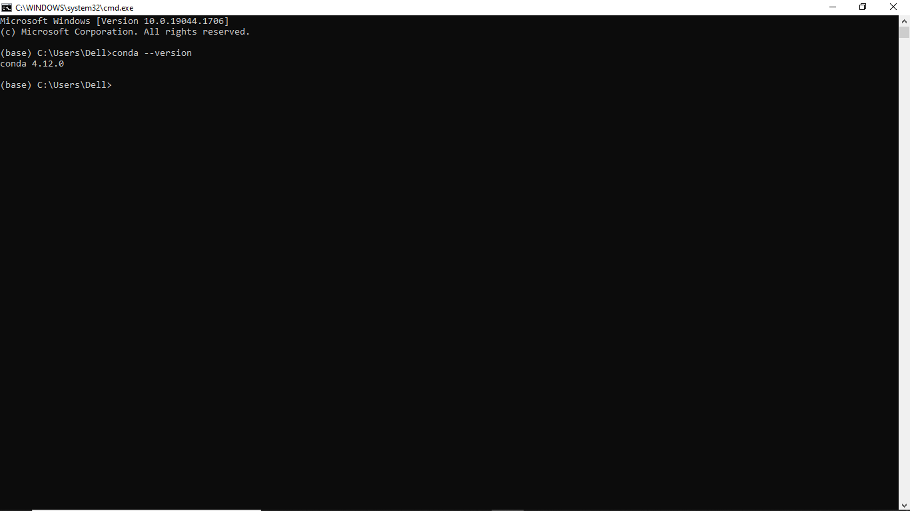

**To build Machine learning models we installed the following packages:**

* Sklearn
* NumPy
* Pandas
* Matplotlib
* Flask

### Prior Knowledge

we refered the given videos and gain the required knowledge